Could humans live to 500 years old? Scientists believe genetic tweaks could significantly extend our lifespan
- Californian scientists tweaked two genetic pathways in the worm Caenorhabditis elegans to amplify its lifespan
- They said the worms lived to the human equivalent of 400 to 500 years
- Research raises the prospect of anti-ageing treatments based on genetic interactions, and the next step is to investigate if the effects occur in mice
By Sarah Griffiths
PUBLISHED: 06:16 EST, 13 December 2013 | UPDATED: 06:40 EST, 13 December 2013

1,821 shares

418
View
comments

Living to the ripe old age of 500 might be a possibility if the science shown to extend worms' lives can be applied to humans, scientists have said.
U.S. researchers tweaked two genetic pathways in the tiny lab worm Caenorhabditis elegans and boosted the creature's lifespan by a factor of five.
The research raises the prospect of anti-ageing treatments based on genetic interactions, they said.
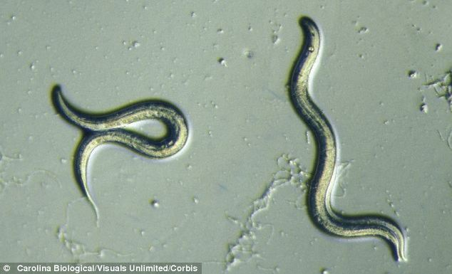
U.S. scientists tweaked two genetic pathways in the tiny lab worm Caenorhabditis elegans (pictured) and boosted the creature's lifespan by a factor of five
‘What we have here is a synergistic five-fold increase in lifespan,’ said lead scientist Dr Pankaj Kapahi, from the Buck Institute of Age Research, Novato, California.

More...
- You CAN smell fear: Aromas bring back bad memories because the sense is more active when we are frightened
- Birth of the ROBO-SPERM: Scientists create first cyborg sperm that can be remote-controlled using magnets
‘The two mutations set off a positive feedback loop in specific tissues that amplified lifespan.
‘Basically these worms lived to the human equivalent of 400 to 500 years.’
Living to the age of 500 might be a possibility if the science shown to extend worms' lives can be applied to humans, scientists said. Two mutations set off a positive feedback loop in specific tissues that enabled worms to live to the human equivalent of 400 to 500 years
While it could take years of research to extend humans’ lives dramatically, the study raises the prospect of anti-ageing treatments informed by genetic interactions, according to Dr Kapahi.
‘In the early years, cancer researchers focused on mutations in single genes, but then it became apparent that different mutations in a class of genes were driving the disease process,’ he said.
While it could take years of research to extend humans' lives, the study raises the prospect of anti-ageing treatments informed by genetic interactions
‘The same thing is likely happening in ageing,’ he added.
C. elegans, the first animal to have its whole genome (or genetic code) mapped, has been widely used in studies of ageing and lifespan.
The new research, reported in the journal Cell Reports, involved blocking key molecules that affect the action of insulin and a nutrient signalling pathway called Target of Rapamycin (TOR).
Single mutations in the TOR pathway were known to extend the lifespan of C. elegans by 30 per cent, while insulin-signalling mutations could double the amount of time they lived.
Adding the two together might have been expected to extend longevity by 130 per cent, but the combined impact turned out to be much greater.
The research may explain why it has proved so difficult to identify single genes responsible for the long lives enjoyed by human centenarians.
‘It's quite probable that interactions between genes are critical in those fortunate enough to live very long, healthy lives,’ said Dr Kapahi.
Future research is expected to use mice to see if the same effects occur in mammals.
‘The idea would be to use mice genetically engineered to have suppressed insulin signalling and then treat them with the drug rapamycin, which is well-known to suppress the TOR pathway,’ Dr Kapahi said.

SCIENTISTS FIND DEATH CAN BE SEEN SPREADING AS A BLUE GLOWING WAVE THROUGH THE BODY OF A WORM
Earlier this year British scientists captured death spreading like a wave through the body of a worm, by studying the blue fluorescence that travels cell-to-cell until the whole organism is dead.
Researchers from the Wellcome Trust and the Biotechnology and Biological Sciences Research Council (BBSRC) likened the spread of the blue glow travelling through the worm's body to that of the Grim Reaper, stalking death.
They believe that the research could eventually prove to be a useful model to understanding death in people and perhaps even lead to an increase in life expectancy.
When individual cells die, they trigger a chemical chain reaction that leads to the breakdown of cell components and a build-up of molecular debris.
The molecular mechanisms of this are reasonably well understood at a cellular level but we know much less about how death spreads throughout an organism at the end of its life.
In worms, the spread of death can be seen easily under a microscope as a wave of blue fluorescence travelling through the gut of the worm.
The study, published in PLoS Biology, reveals that this fluorescence is caused by a cell death pathway called necrosis and its spread throughout the organism is dependent on calcium signalling.
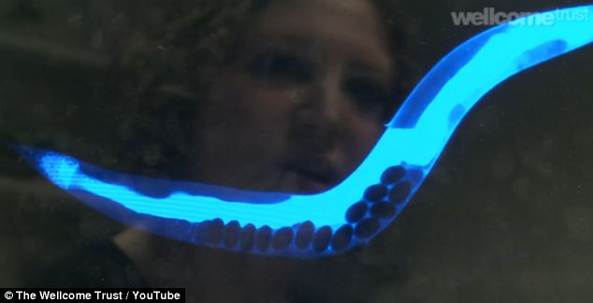
In worms, the spread of death can be seen easily under a microscope as a wave of blue fluorescence travelling through the gut of the worm (pictured). This fluorescence is caused by a cell death pathway called necrosis and its spread throughout the organism is dependent on calcium signalling
Read more: http://www.dailymail.co.uk/sciencetech/article-2523086/Could-humans-live-500-years-old-Scientists-believe-genetic-tweaks-significantly-extend-lifespan.html#ixzz2nTSI1pQZ
Follow us: @MailOnline on Twitter | DailyMail on Facebook

